Couplet Rhyme

🔹 What is Couplet Rhyme
# Source: Chatgpt (GPT-4-turbo) at [8/2/2025]
⚠️ Couplet rhyme is a poetic rhyme pattern, not a type of homograph. However, homographs can appear within rhyming couplets depending on pronunciation and stress.

✅ Definition of Couplet Rhyme
# Source: Chatgpt (GPT-4-turbo) at [8/2/2025]
Couplet rhyme occurs when two consecutive lines of poetry end in rhyming words — typically following the AA rhyme scheme.
These rhyming pairs form a “couplet”: a set of two lines that rhyme and often complete a thought.

🧠 Key Features
# Source: Chatgpt (GPT-4-turbo) at [8/2/2025]
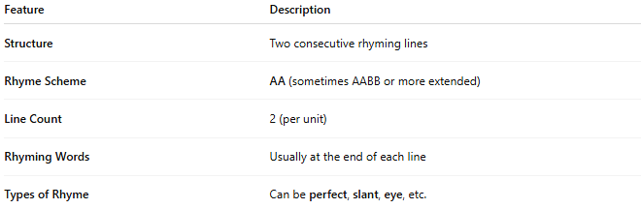
Feature | Description
Structure | Two consecutive rhyming lines
Rhyme Scheme | AA (sometimes AABB or more extended)
Line Count | 2 (per unit)
Rhyming Words | Usually at the end of each line
Types of Rhyme | Can be perfect, slant, eye, etc.

📝 Example of Couplet Rhyme (Perfect Rhyme)
# Source: Chatgpt (GPT-4-turbo) at [8/2/2025]
“The sky grew dark, the winds blew cold
A storm was coming, fierce and bold.”
🔹 cold / bold = perfect rhyme forming a couplet rhyme.

🧪 Using Homographs in Couplet Rhyme
# Source: Chatgpt (GPT-4-turbo) at [8/2/2025]
When homographs are used at the end of couplet lines and their pronunciation matches, they can contribute to rhyme:
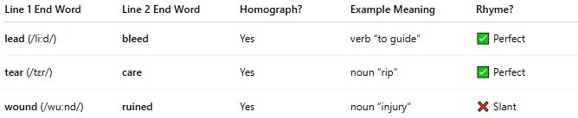
Line 1 End Word | Line 2 End Word | Homograph? | Example Meaning | Rhyme?
lead (/liːd/) | bleed | Yes | verb “to guide” | ✅ Perfect
tear (/tɛr/) | care | Yes | noun “rip” | ✅ Perfect
wound (/wuːnd/) | ruined | Yes | noun “injury” | ❌ Slant

✅ Types of Rhyme within Couplets
# Source: Chatgpt (GPT-4-turbo) at [8/2/2025]
Couplet rhyme may feature many kinds of rhyme:
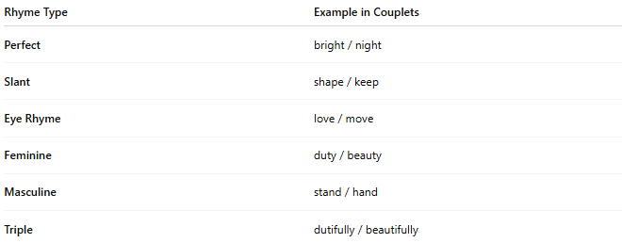
Rhyme Type | Example in Couplets
Perfect | bright / night
Slant | shape / keep
Eye Rhyme | love / move
Feminine | duty / beauty
Masculine | stand / hand
Triple | dutifully / beautifully
Homographs can appear in any of these if their pronunciation fits.

✅ Summary
# Source: Chatgpt (GPT-4-turbo) at [8/2/2025]
- Couplet rhyme refers to two rhyming lines, not to a word type.
- Homographs may appear in couplet rhymes if they:
  - Are placed at the end of rhyming lines
  - Share the same pronunciation and stress
- Works with all types of rhyme (perfect, slant, feminine, etc.).

